A bus has n stops numbered from 0 to n - 1 that form a circle. We know the distance between all pairs of neighboring stops where distance[i] is the distance between the stops number i and (i + 1) % n.

The bus goes along both directions i.e. clockwise and counterclockwise.

Return the shortest distance between the given start and destination stops.

**Example 1:**

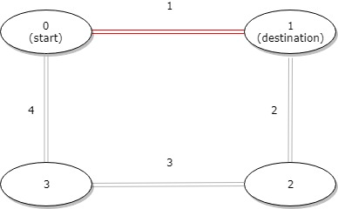

**Input:** distance = [1,2,3,4], start = 0, destination = 1

**Output:** 1

**Explanation:** Distance between 0 and 1 is 1 or 9, minimum is 1.

**Example 2:**

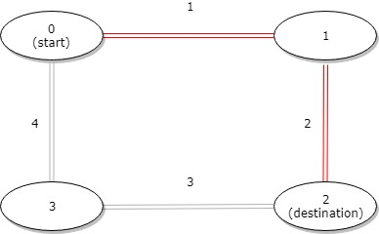

**Input:** distance = [1,2,3,4], start = 0, destination = 2

**Output:** 3

**Explanation:** Distance between 0 and 2 is 3 or 7, minimum is 3.

**Example 3:**

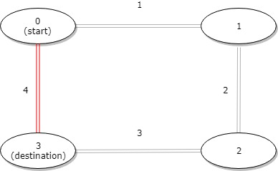

**Input:** distance = [1,2,3,4], start = 0, destination = 3

**Output:** 4

**Explanation:** Distance between 0 and 3 is 6 or 4, minimum is 4.

**Constraints:**

* 1 <= n <= 10^4
* distance.length == n
* 0 <= start, destination < n
* 0 <= distance[i] <= 10^4